localhost/phpmyadmin

DATABASE NAME- dbsql

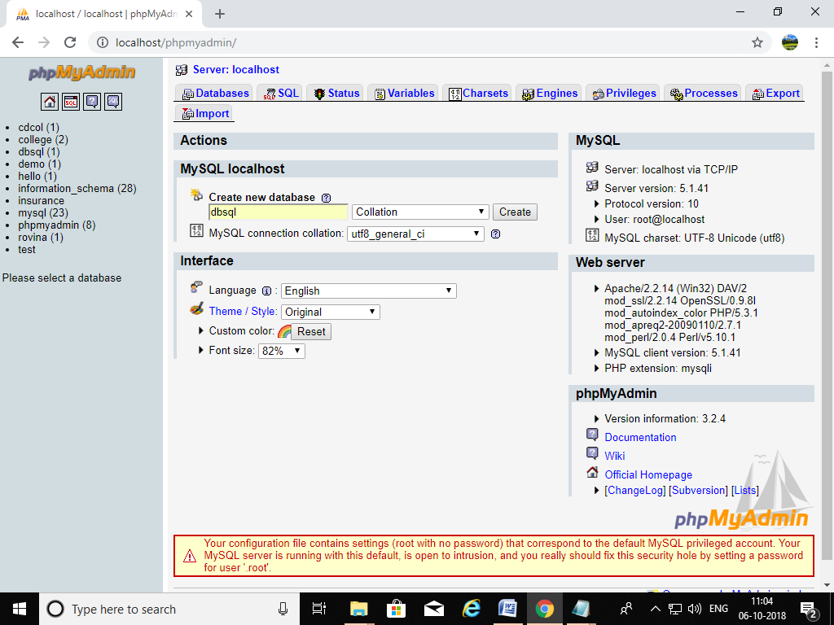

TABLE NAME- product

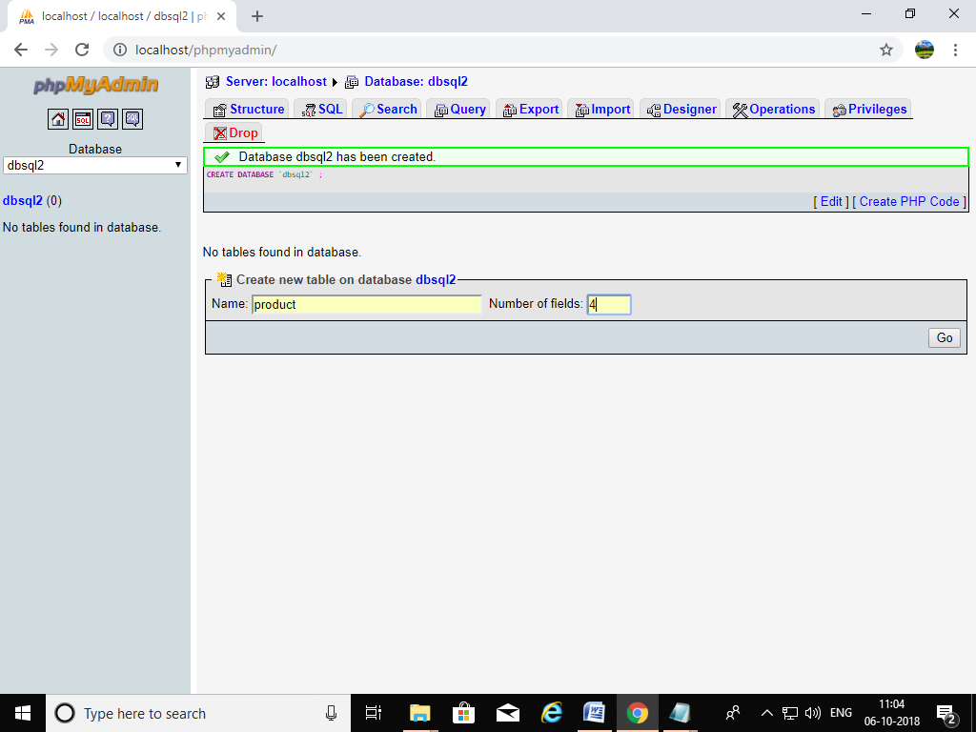

Attributes of product- productid int(10), pname varchar(10), price int(10), description varchar(10)

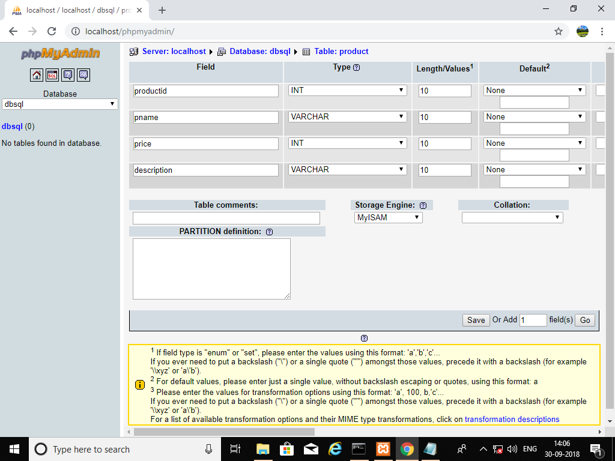

**title.html**

<html>

<head>

<title>SELECT</title>

</head>

<body>

<h3>Select the Option to be performed</h3>

<br>

<a href="insertion.html">Add a Record</a>

<br>

<a href="deletion.html">Remove a Record</a>

<br>

<a href="updation.html">Update a Record</a>

<br>

<a href="displaying.php">Display all records</a>

</body>

</html>

**OUTPUT-**

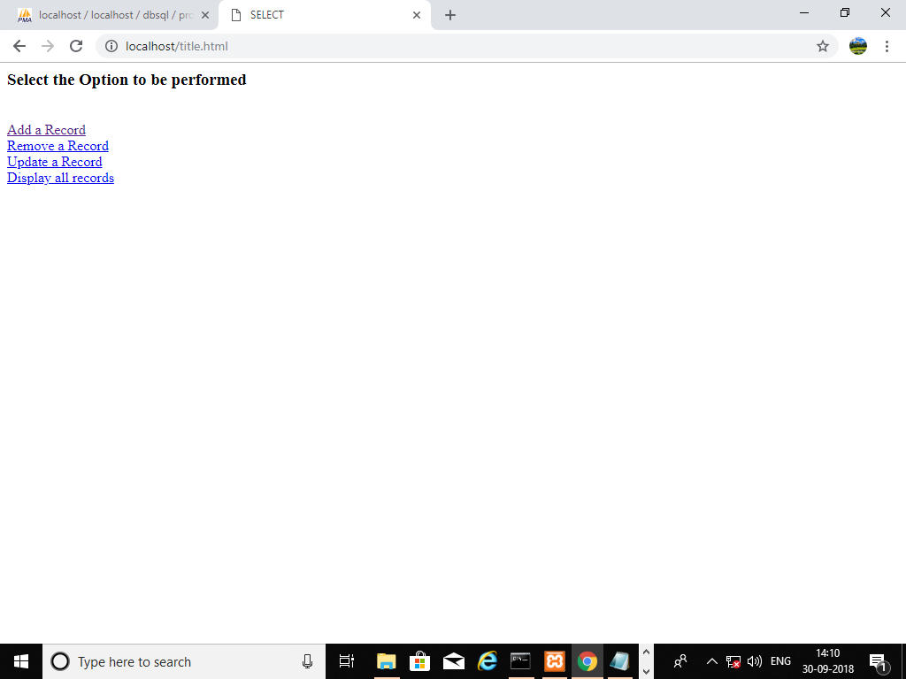

**ADD A RECORD**

**insertion.html**

<html>

<body>

<form action="insertion.php" method="post">

productid:<input type="text" name="t1"><br><br>

pname:<input type="text" name="t2"><br><br>

price:<input type="text" name="t3"><br><br>

description:<input type="text" name="t4"><br><br>

<input type="submit" name="submit" value="Insert">

</form>

</body>

</html>

**insertion.php**

<?php

$t1=$_POST["t1"];

$t2=$_POST["t2"];

$t3=$_POST["t3"];

$t4=$_POST["t4"];

mysql_connect("localhost", "root","") or die (mysql_error());

echo "Connection to server successful !<br>";

$dbase_name="dbsql";

mysql_select_db($dbase_name) or die (mysql_error());

echo "Database is selected.<br>";

$query="insert into product values('$t1','$t2','$t3','$t4')";

mysql_query($query) or die (mysql_error());

echo "Data successfully inserted.";

mysql_close();

?>

**OUTPUT-**

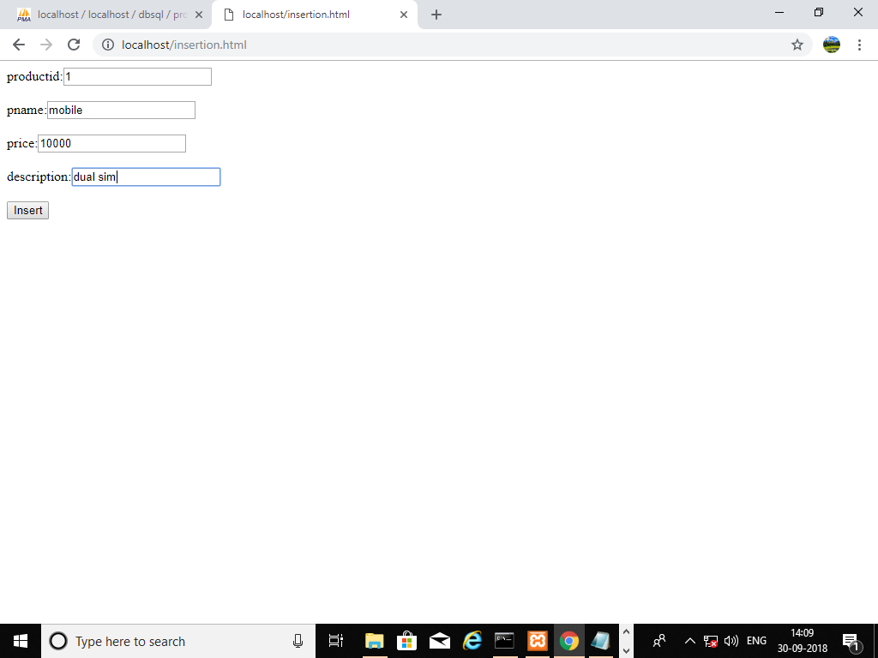

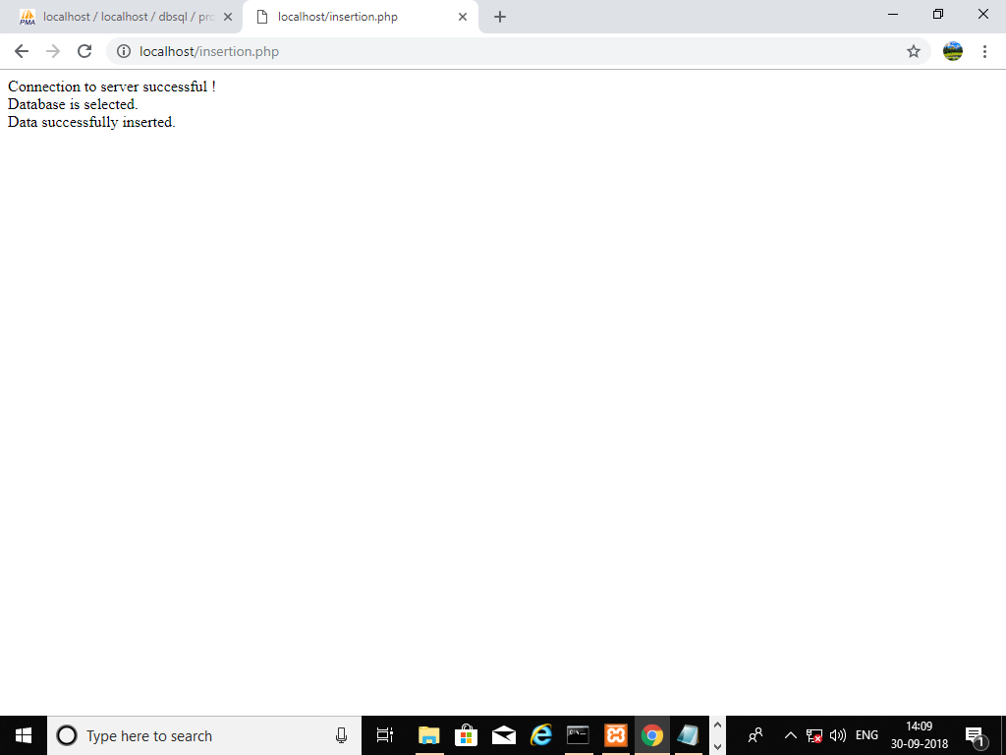

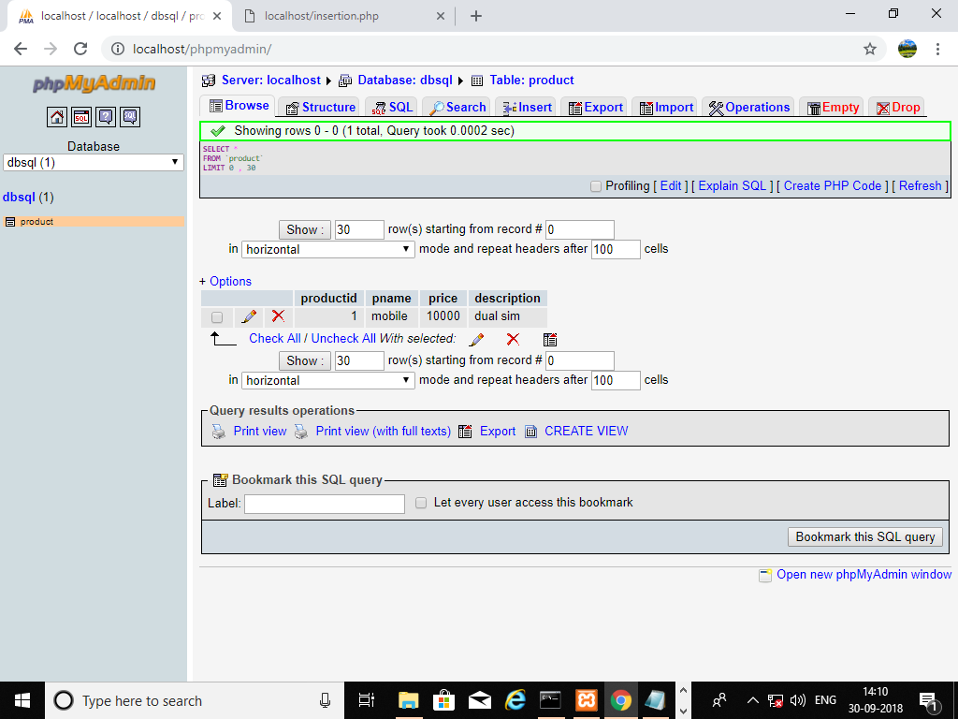

Insert 4 records

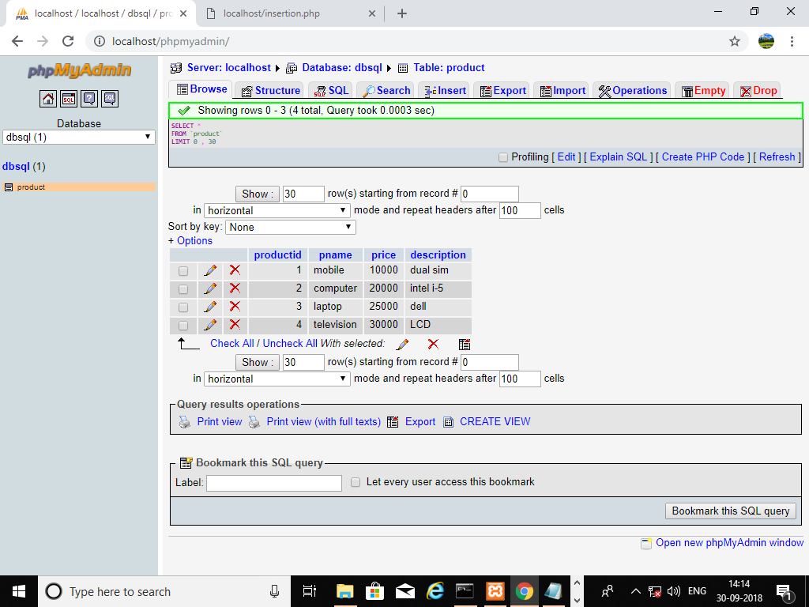

**REMOVE A RECORD**

**deletion.html**

<html>

<body>

<form action="deletion.php" method="post">

productid:<input type="text" name="t1"><br><br>

<input type="submit" name="submit" value="DELETE">

</form>

</body>

</html>

**deletion.php**

<?php

mysql_connect("localhost","root","") or die(mysql_error());

echo "Connection to the server was successful!";

$dbase_name="dbsql";

mysql_select_db($dbase_name) or die(mysql_error());

echo "Database is selected";

$id=$_POST['t1'];

$query="delete from product where productid=$id";

mysql_query($query) or die(mysql_error());

echo "Data Successfully deleted";

mysql_close();

?>

**OUTPUT-**

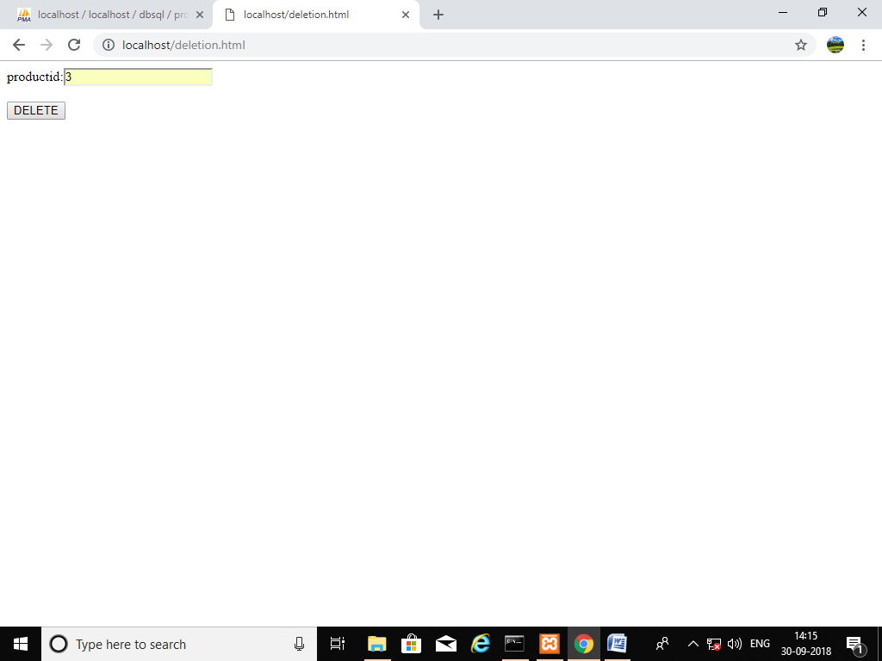

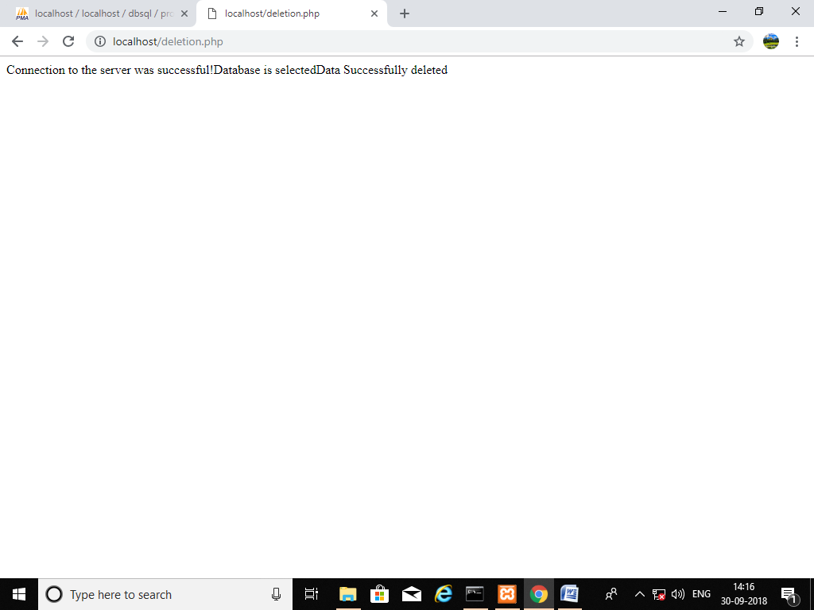

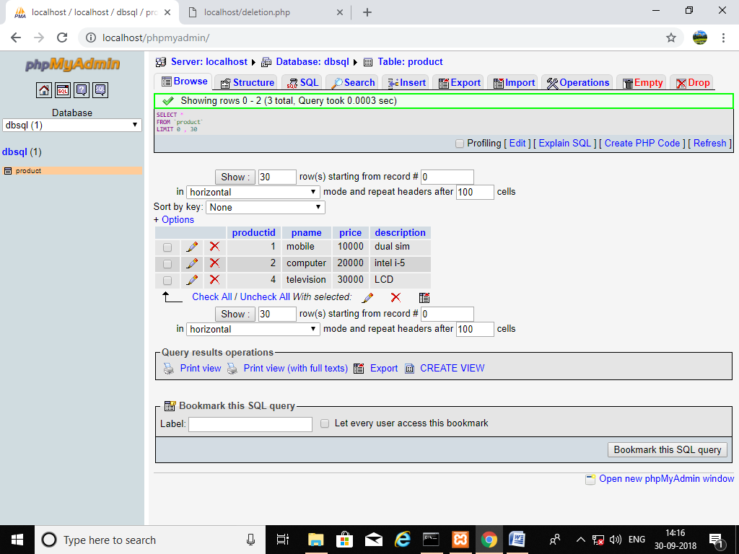

**UPDATE A RECORD**

**updation.html**

<html>

<body>

<form action="updation.php" method="post">

productid:<input type="text" name="t1"><br><br>

price:<input type="text" name="t3"><br><br>

<input type="submit" name="submit" value="Insert">

</form>

</body>

</html>

**updation.php**

<?php

mysql_connect("localhost","root","") or die(mysql_error());

echo "Connection to the server was successful!";

$dbase_name="dbsql";

mysql_select_db($dbase_name) or die(mysql_error());

echo "Database is selected";

$id=$_POST['t1'];

$newprice=$_POST['t3'];

$query= "update product set price='$newprice' where productid='$id' ";

mysql_query($query) or die(mysql_error());

echo "Data Updated Successfully";

mysql_close();

?>

**OUTPUT-**

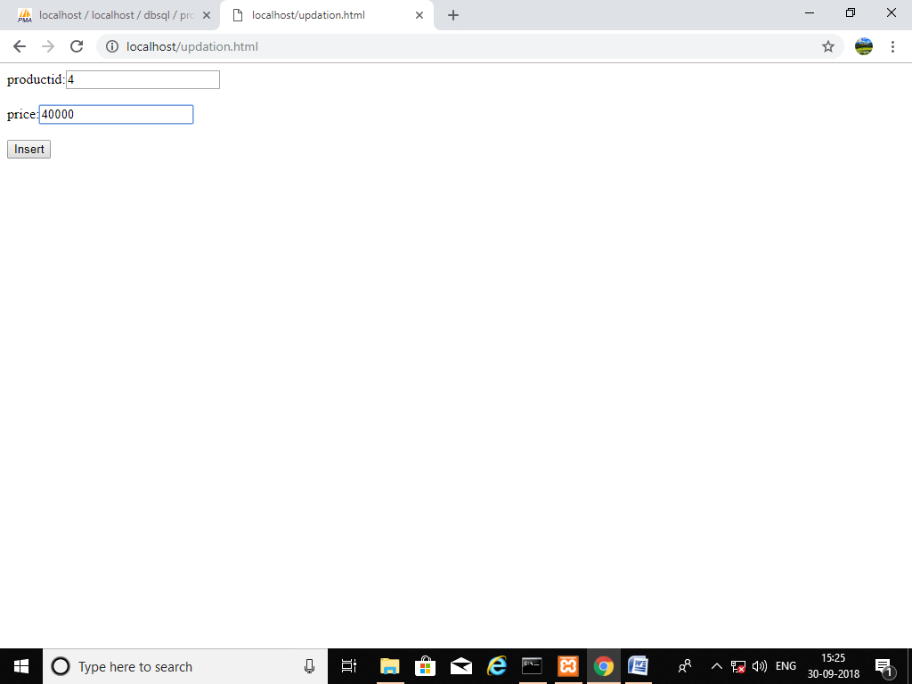

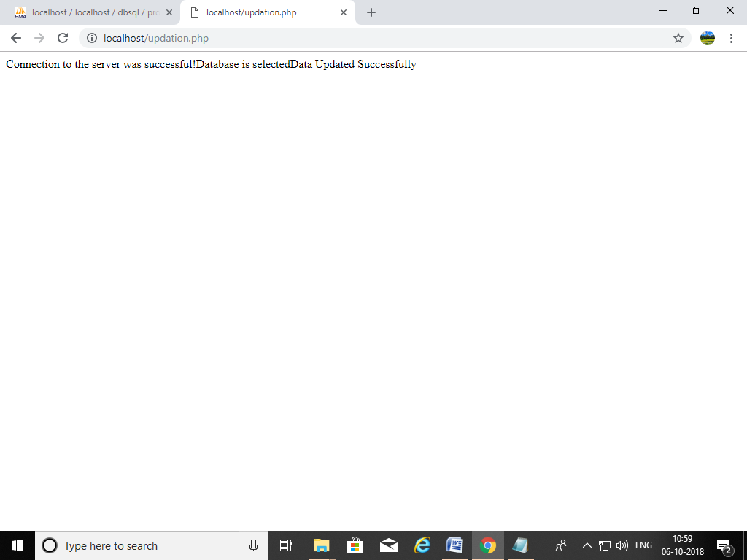

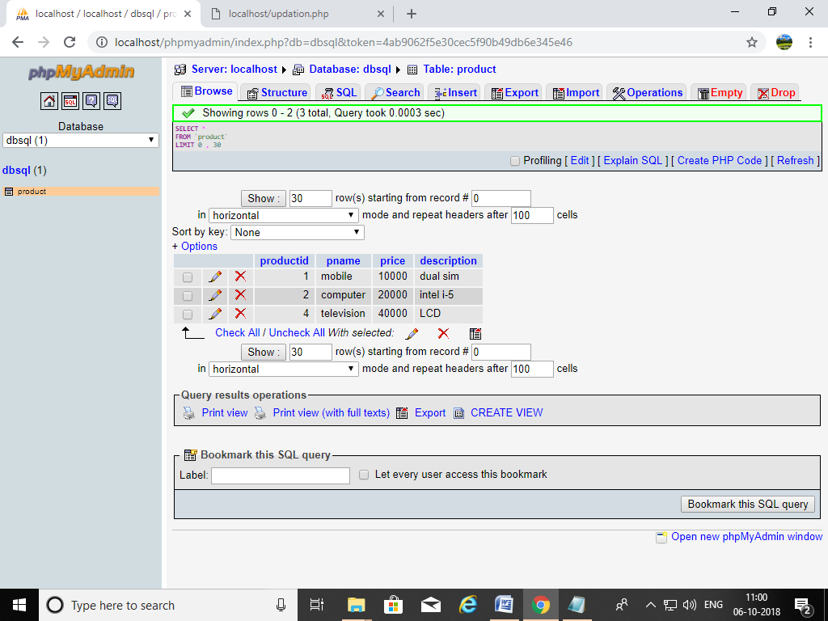

**DISPLAY THE RECORDS**

**displaying.php**

<?php

mysql_connect("localhost","root","") or die (mysql_error());

echo "Connection Success";

$dbase_name="dbsql";

mysql_select_db($dbase_name)or die (mysql_error());

echo "Database is selected";

$query=("select * from product");

$result=mysql_query($query);

echo "<table>";

while($row = mysql_fetch_array($result))

{

echo "<tr><td>" . $row['product_id'] . "</td><td>" . $row['pname'] . "</td><td>" . $row['price'] . "</td><td>" . $row['description']. "</td></tr>";

}

echo "</table>";

?>

**OUTPUT-**

